# Skillpipe Access

**Course URL:**

<https://learn.microsoft.com/en-us/training/courses/az-104t00?WT.mc_id=ilt_partner_webpage_wwl&ocid=5372415#study-guide?WT.mc_id=ilt_partner_webpage_wwl&ocid=5372415#study-guide>

**Achievement URL:**

<https://learn.microsoft.com/en-us/users/me/achievements?WT.mc_id=ilt_partner_webpage_wwl&ocid=5372415&source=learn&redeem=3GL3K5>

**3GL3K5**

**Mandatory Google form Link:**

<https://forms.gle/LQvLdw9HEihHg3fX6>

**Steps to access Skillpipe E-learning Microsoft Azure Admin-104:**

**To get an Intellipaat certificate, please do the following tasks and fill out the google form link mentioned at the bottom of the document.**

***Note:* Please use your Micorosft Account to do the following tasks.**

**Step 1:**

**Click on the achievement URL provided to you in the mail. You will get a coupon code:**

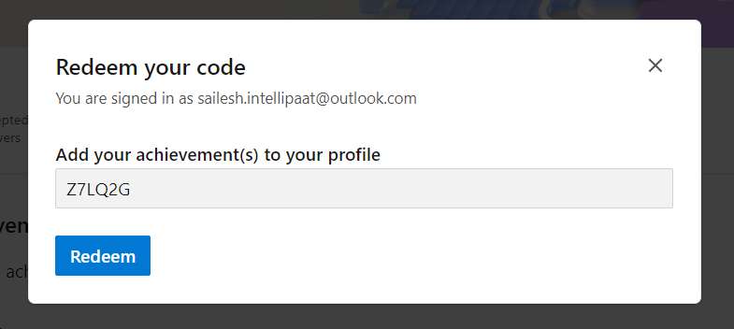

You need to click on **Redeem button**.

You will see the below screen.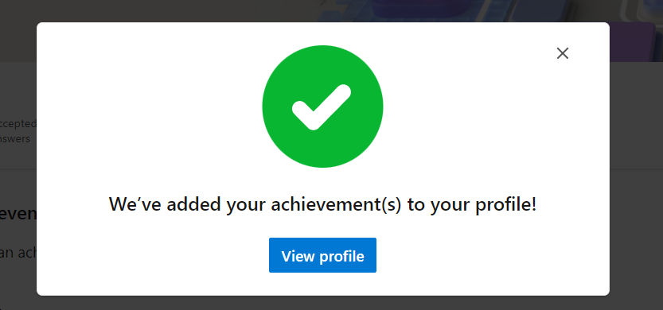

**Step 2: Click on View Profile and you will be redirected to the following page where you can find all the learning material, and badges(that you can use on Social Platform).**

**Mandatory**

**Google Form Link: <https://forms.gle/LQvLdw9HEihHg3fX6>**

